**EV Hackathon** - **Team EVlution**

We chose to tackle the 1st and 2nd use cases in the Electric Vehicle (EV) hackathon by creating a simulation model to predict the load curve from EVs in Ontario and experiment incentivize load shifting.

Our approach to the problem was Agent Based Modelling. Agent based models (ABM) are stochastic models built from the bottom-up meaning is a method of simulation whereby the user can program individual actors (agents) with behaviours and attributes, then agents act in a stepwise nature (each agent acting once per step). The resultant model allows the exploration of complex systems that display non-independence of individuals and feedback loops in causal mechanisms.

Our ABM simulated individual EVs moving around a region, between different points of interest (POIs) randomly assigned to them such as their home, work, or random POIs. We gave these agents schedules to follow for work and holidays, which determined where an agent might go and how long they would stay there. By measuring their movement, we can determine their energy use and subsequent need to recharge. We then gave the agents charging behaviours to determine where and when the agents might charge based off a pricing mechanism related to their need to charge.

Figure 1 - Left: ABM simulation for live running. Centre: Live model statistics. Right: PowerBI Dashboard from collected runs.

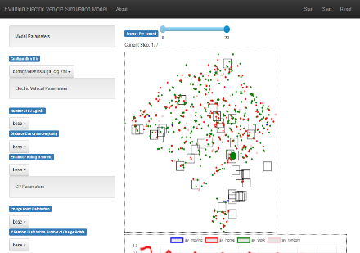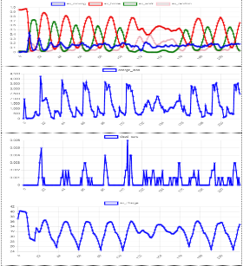

To demonstrate the model we built a visualisation page where the user or client can change any model parameters and run the model in real time to see the agents moving around the grid between their POIs (Figure 1 – left), and collect live model observables from the aggregate agent behaviours, e.g. the live load curve from agents that are charging (Figure 1 – centre).

Experiments can also be done by creating many model runs with different parameters and random seeds, then compare results. In this way we can examine different geographies, and look at the overall load curve as observed in different regions. We demonstrate this via a PowerBI dashboard which collects all our data from the SQL database, and loads it to a dashboard, where we can drill into different runs and see the load curves on specific dates, overall weekday/weekend split, or in aggregate between regions etc.

A lack of relevant data availability was one of the main challenges for this project with little information on existing load curves of EVs but the data we did have was collected into a data pipeline. We parametrised the model based on the available data and then made a series of assumptions on agent attributes, then collected these to store them in configuration for model runs.

To explore the effect of EV charging on the environment and tackle the second use case, we propose running experiments adjusting the pricing mechanism as implemented in the model, to incentivize EV users to charge when it’s cheaper and load shifting toward the load curve from the generation of renewable energy.

This model currently makes many assumptions for how EV agents act and their core attributes and behaviours, by working with client facing model and visualisations as seen above, so that the client can tailor assumptions and parameters using their insights. Then use the batch experiments to pull levers to see the effects on the model outcomes via the dashboards, and experiment with incentives for load shifting.

Further work could focus on data collection to drive smarter EV agent behaviours and better parameter estimation functions, adding in seasonal and more geolocation data, to add new regions or wider areas and to incorporate into model of full load curve.